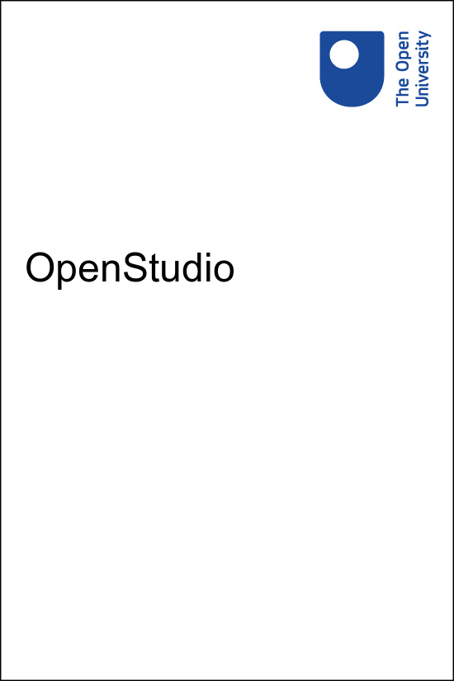

Copyright © 2019 The Open University

All rights reserved. No part of this publication may be reproduced, stored in a retrieval system, transmitted or utilised in any form or by any means, electronic, mechanical, photocopying, recording or otherwise, without written permission from the publisher.

# Contents

* Introduction
* Studio tabs
* Your profile
  + Viewing others’ profiles
* Uploading content
  + Upload form
* Uploading to a folder
  + Within a folder
  + Add posts to a folder
  + Order posts within a folder
* Review, edit and delete content
  + Versioning
  + Restoring deleted posts
* Social interaction
  + Feedback
  + Commenting
  + Flags
  + Reporting posts
* Notifications
  + Hiding notifications
  + Email subscription
* Locked posts and folders
  + Filters
* Export and import
  + Export
  + Import
* Teachers: multiple groups
* Using OpenStudio on a mobile device
* Accessibility

## Introduction

OpenStudio is an activity that allows you to share content with other students on your course; it can be shared with your teaching group or used as an individual work portfolio. OpenStudio is a creative, collaborative space for you to work as if you are physically in a design studio, sharing work with teachers and other students, getting feedback, and commenting on the work of others.

Start of Figure

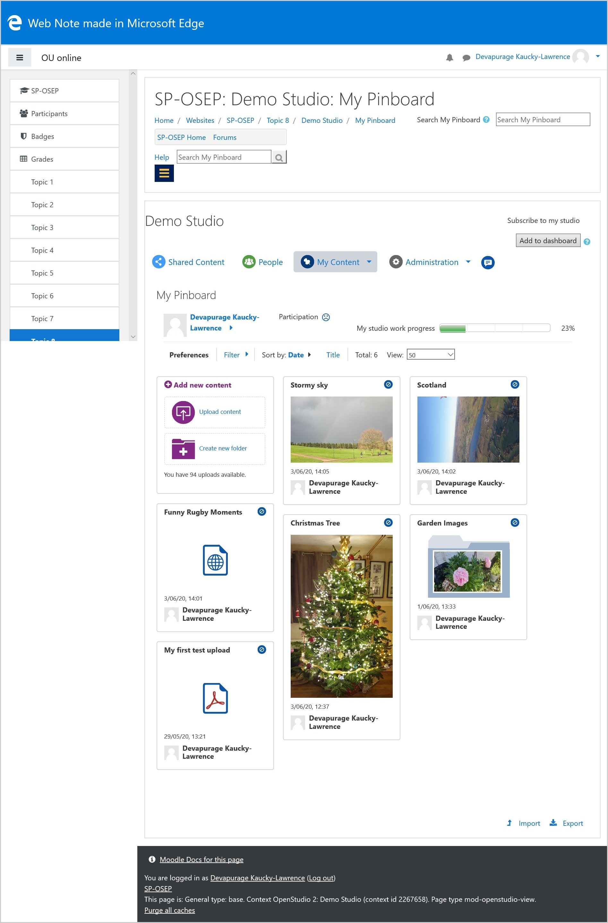

An example OpenStudio

End of Figure

Start of Box

End of Box

Start of Box

**Plagiarism and OpenStudio**

When you first start OpenStudio, you may be asked to accept the terms of use to continue. Like any work you submit it is expected to be your own, or the true author acknowledged through citation and referencing.

End of Box

## Studio tabs

When accessing OpenStudio, tabs are displayed at the top of the page that enable you to navigate to the different areas of the studio.

Start of Figure

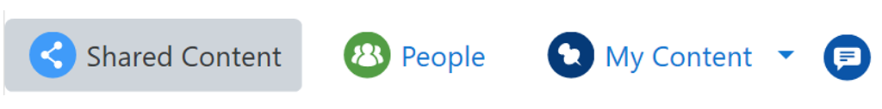

Tabs available in OpenStudioEnd of Figure

The tabs available (and any subsequent areas within them) depend on the set up of the OpenStudio but most include 'My Pinboard' (accessed from 'My Content') and 'My Module' (accessed from 'Shared Content).

**Note**: the names of some of the tabs and areas can be changed as part of the set up but their functionality should be the same. The names of the 'My Content' and 'Shared Content' tabs cannot be changed, but areas within tabs can be renamed.

## Shared Content

Selecting the Shared Content tab will bring up a drop-down menu for any areas that contain content visible to others. Common areas are:

### My Group

My Group is a group share space. This area displays any posts you have shared (from My Pinboard or My Activities) with the rest of your group. Content shared in this area may be commented on by other members of the group.

### My Module

My Module is a course share space. This area has the same functionality as My Group but contains work shared with the whole course.

## My Content

Selecting the My Content tab will bring up a drop-down menu for any areas that contain content visible only to you and work relating to your course. Common areas are:

### My Activities

My Activities is your personal, activity-specific space. This area is set up by the teacher and contains predefined posts where you can upload content relating to activities set as part of the course.

### My Pinboard

My Pinboard is your personal space where you are able to upload content. Once uploaded, you have the option to keep the post private, or share it with other members of the group/module.

Start of Box

Note if there is only one area within the 'My Content' and/or 'Shared Content' tabs, no drop-down menu will appear and selecting this tab will take you straight to the area page.

End of Box

## People

People enables you to view the participation and progress of other active members of your group and/or course depending on how it has been set up.

Start of Figure

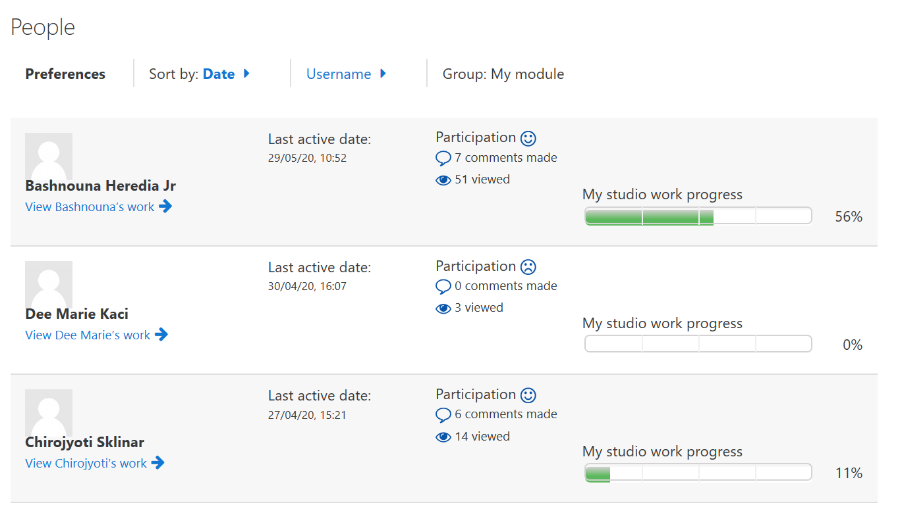

The People tab of an OpenStudioEnd of Figure

You are able to see when the user was last active, how many comments they have made, how many posts they have viewed and their progress towards their studio work for each active profile.

Links to view the profiles of other users are also available underneath the name of their profile. For more information on viewing someone else's profile, see the Viewing others’ profiles section of this document.

## Your profile

To view your profile, navigate to any area within the 'My Content' tab ('My Activities' or 'My Pinboard' for example).

At the top of the page you will see your profile, which shows your participation and progress as a percentage.Start of Figure

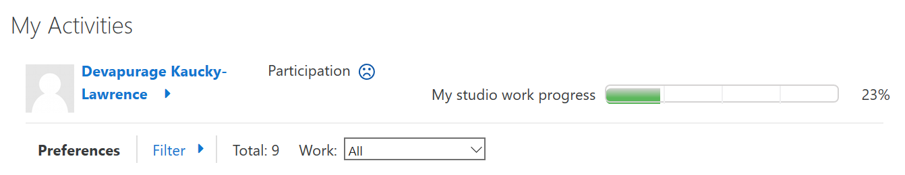

Example profileEnd of Figure

The 'My studio work progress' bar indicates the percentage of work done in OpenStudio and is linked **only** to the 'My Activities' area.

If the 'My Activities' area is not set up then you will not see this progress bar.

Depending on how your OpenStudio has been set up, you might also see a ‘My participation’ icon in the form of a happy or unhappy face. This encourages commenting on others' work more than you upload content and will only smile when commenting is greater than uploads.

To see more details about your participation, click on the arrow next to your profile name. This will expand your profile to give you details about when you were last active, the number of comments you have made and how many posts you have viewed.

You will also be able to see the progress you have made towards each activity. A box will be displayed for each activity within each activity, with the boxes indicating if you have completed that part of the activity. To minimise this again, click on the downward facing arrow next to your name.

Start of Figure

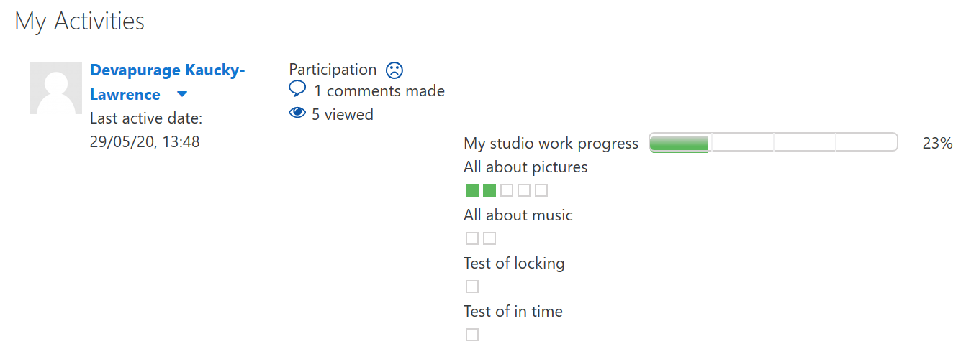

Expanded example profileEnd of Figure

## Viewing others’ profiles

Depending on how the OpenStudio has been set up, you might be able to view other users' profiles and posts.

If enabled, navigate to content posted by the user – under SHARED CONTENT and select the View Name's work link underneath their name. This link can be accessed either from within a post, by using the link within the 'Owner of this post' box, or from an area page, using the link underneath the preview of the post.

Start of Figure

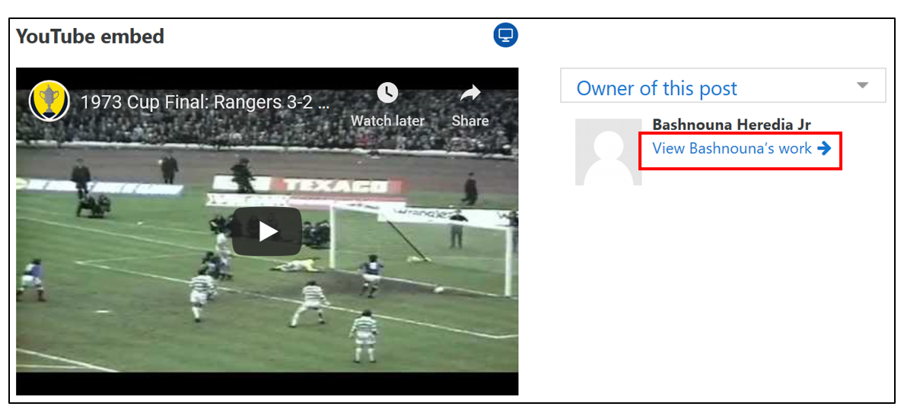

Profile linkEnd of Figure

What you are able to see once the link has been selected will depend on the settings for that studio.

You might be able to see full profile information, including their participation record and their My studio work progress. You might also be able to see what they have uploaded for their studio work and/or what they have uploaded to their pinboard underneath the profile information. Start of Figure

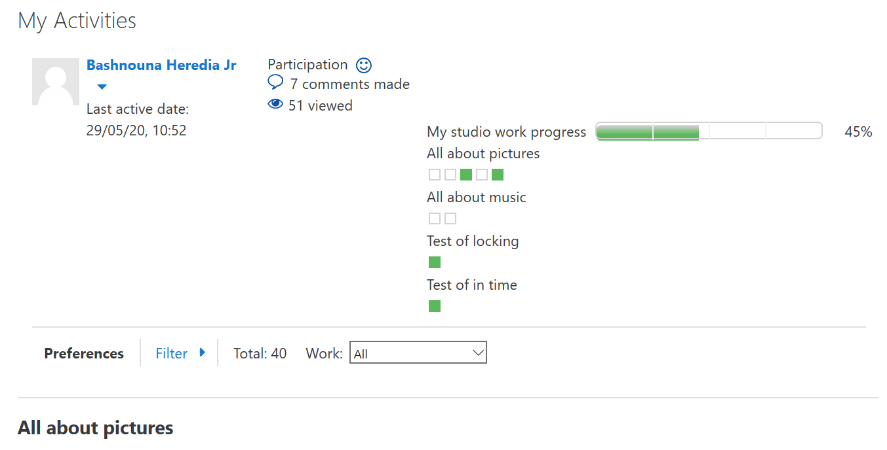

Example profile pageEnd of Figure

## Uploading content

OpenStudio allows you to upload and share content through posts.

Posts can either be made through pre-created placeholders, within the 'My Activities' area, or added to the 'My Pinboard' area.

Depending on how your OpenStudio has been set up, you can usually edit your own posts at any time by clicking on them.

You can add text, tags (metadata) and/or the following content:

* a file
* a web link URL or reference
* HTML embed code acquired from third-party sources such as YouTube, Pinterest, etc.

**Uploading content to (a) My Pinboard; (b) My Activities pre-created slot**

1. Start of Figure

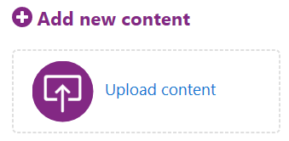

My Pinboard upload area

End of Figure

1. Start of Figure

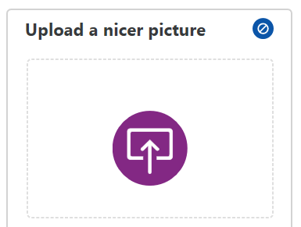

An example empty My Activities pre-created post

End of Figure

To upload to a post:

1. Navigate to your 'My Pinboard' or 'My Activities' area.
2. In '**My Pinboard**', click on the upload icon, or the Add new content link to upload content to a new post.

Although the 'My Module' and 'My Group' areas are for sharing, not creating, work, you can also find the upload icon here as well. If you choose to upload from here, the content will be added to your Pinboard. You may be able to choose to share the content with your Group or your Module, depending how OpenStudio has been set up.

In '**My Activities**', find the relevant predefined post and click on the 'upload' icon in the empty post.

1. Complete the upload form.

The number of posts you can add to your Pinboard is limited and varies depending on how it has been set up. The number of posts you have remaining will be indicated underneath the upload icon. Start of Box

**'Required' posts**

Some posts (if related to a TMA for example) may look slightly different when viewed in My Activities, with a light yellow background.

Start of Figure

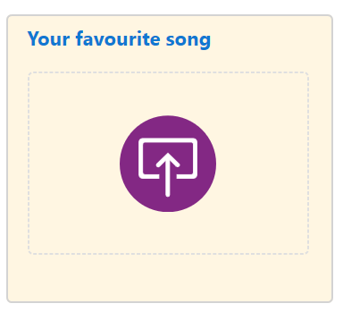

An example empty required My Activities pre-created post

End of Figure

End of Box

## Upload form

To complete the upload form:

1. Set the visibility of your post using the drop-down menu. Depending on how your OpenStudio is set up, you may have several options:
   * Only me – only I can see it
   * Group – visible to my group or subgroup members
   * My module – visible to my module members
   * My tutor - only your teacher can see this. Your work will automatically show in your teacher’s My Group area only, and is highlighted with the same icon for them.

Once you have saved your post, the visibility icon will be displayed on the right-hand side of the page when viewing the post and in the top right-hand corner of the post preview when being viewed from an area page.

1. Fill in the title and description fields as it may help you (and others) find posts in the future, especially if your course has a lot of activities and posts.

Start of Figure

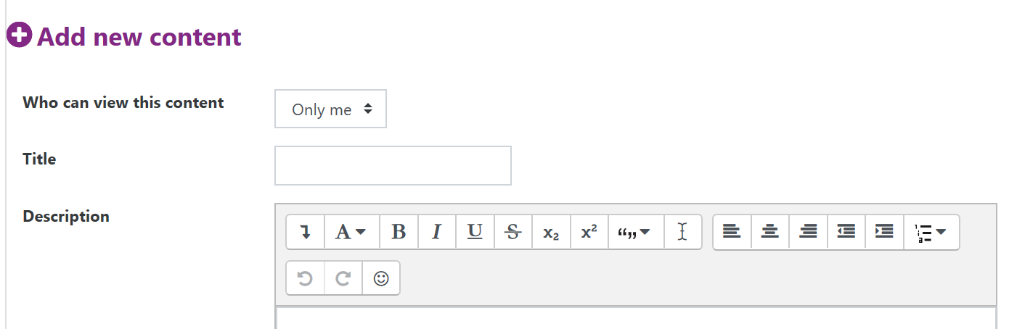

Top of the upload form

End of Figure

1. Next you must select either Add file or Add web/embed link depending on what you wish to upload to your post.
   * **Add file** – Before you start to upload a file, be sure that you can upload it – the form will say how many uploads you can make and how big the file(s) can be.

Further information on uploading files can be found in the [Text editor](https://learn1.open.ac.uk/mod/oucontent/olinkremote.php?website=CG&targetdoc=Text%20editor) section of the Computing Guide .

In order to display GPS data and / or image data you also need to select the ‘retain EXIF image data’ box. The EXIF data of the image will then be uploaded with the image. This may include details and settings relating to the camera the image was taken on, orientation details of the image, and possibly the GPS location of where the image was taken. EXIF data can be uploaded without displaying the GPS or image data by selecting the ‘retain EXIF image data’ option only.

Select the appropriate ownership option from 'All my own work' and 'Found elsewhere' by using the radio buttons. If 'Found elsewhere' is selected, the 'Details' field will be enabled for you to fill in the ownership details.

Start of Figure

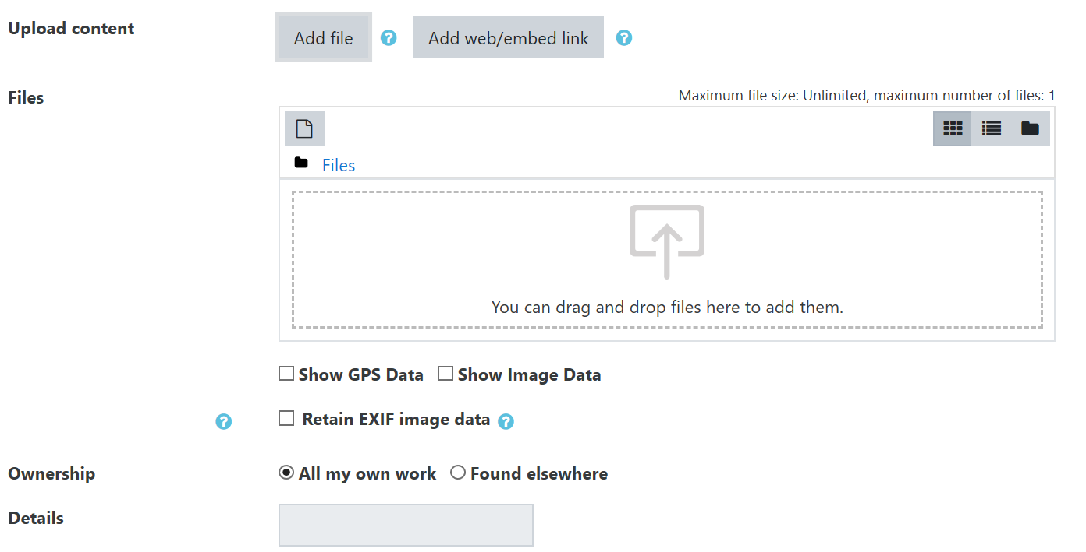

Add file fields of the upload form

End of Figure

* + **Add web/embed link** – Use the 'Web link' field to insert your link or embed code (perhaps instead of a file).

If OpenStudio detects you using a supported third-party website which has embed code available, it will add the code and remove the link information once you click Save. You won't see this until you edit the post later on.

If embedding content, the OU cannot support external websites, the websites OpenStudio should support are listed below.

Select the appropriate ownership option from 'All my own work' and 'Found elsewhere' by using the radio buttons. If 'Found elsewhere' is selected, the 'Details' field will be enabled for you to fill in the ownership details.

Start of Figure

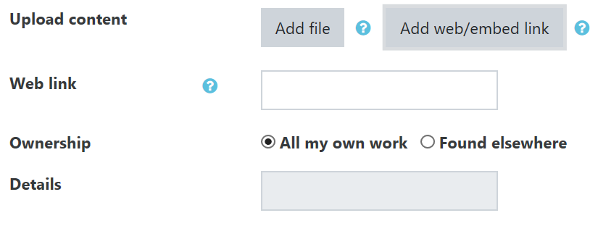

Add web/embed link fields of the upload form

End of Figure

1. At the bottom of the upload form you can add tags so that posts can be grouped together with the same tag. Selecting the downwards facing arrow within the tags box will display any suggested tags for your post.

Start of Figure

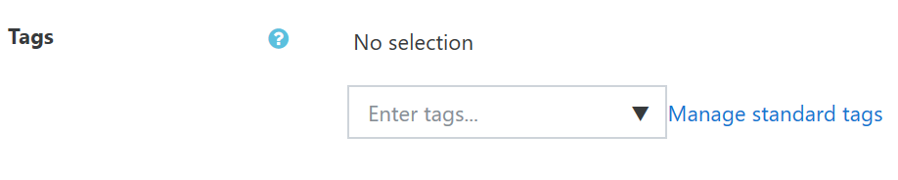

Tags field of the upload form

End of Figure

1. Select Save to post your uploaded content, or select Cancel.

Start of Box

**Supported file types**

These are the file types that OpenStudio can support. Your course may ask for a specific type of file. If so, this will be communicated clearly (e.g. 'Images only').

* Images: jpg, jpe, jpeg, gif, png
* Videos: avi, mpg, mov, mp4, m4v, flv, gif.

Uploading mp4, m4v, and flv files will embed the video regardless of the browser you are using. If you upload any of the other file types (avi, mpg, mov and gif), you may see a link to download the file instead depending on the browser you are using to view your content.

* Audio: aiff, wav, mp3, m4a
* Documents: doc, docx, rtf, pdf, odt, txt
* Slides: ppt, pptx, odp, pdf
* Spreadsheets: xls, xlsx, csv, ods
* 2D/3D drawings: dwg, dxf, skp, stl, stp, svg, eps
* Python notebook: .ipynb (for previewing only)
* Zip files.

End of Box

End of Box

Start of Box

**Keyboard shortcuts**

Some web browsers may not support right-clicking your mouse for paste options. Remember you can use your keyboard to copy and paste text.

**Copying:** For Windows PCs, use Ctrl+C. For Mac, use Command+C.

**Pasting:** For Windows PCs, use Ctrl+V. For Mac, use Command+V.

End of Box

## Uploading to a folder

Folders allows you to group posts together in a meaningful way. If OpenStudio has been set up to enable folders, and depending on how it has been set up, you can add a folder in My Pinboard, and/or upload content to a folder that has been created by your teacher in My Activities.

**(a) Create a folder in My Pinboard; (b) Upload content to My Activities pre-created folder**

1. Start of Figure

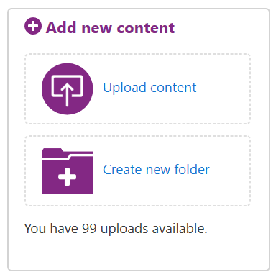

My Pinboard upload area

End of Figure

1. Start of Figure

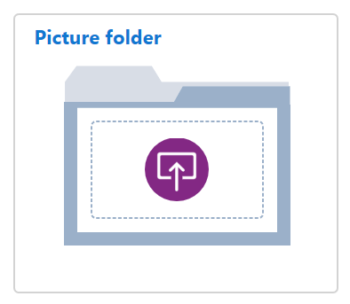

An example empty My Activities pre-created folder

End of Figure

## Create/find a folder

To create a folder in '**My Pinboard**', click on the create new folder icon next to the text 'Create new folder'.

Although the 'My Module' and 'My Group' areas are for sharing, not creating, work, you can also find the create new folder icon here as well.

Pre-created folders are found in the '**My Activities**' area found within the 'My Content' tab.

Start of Box

**'Required' folders**

As with some posts, some folders (e.g. if related to a TMA) may look slightly different when viewed in My Activities, with a light yellow background.

Start of Figure

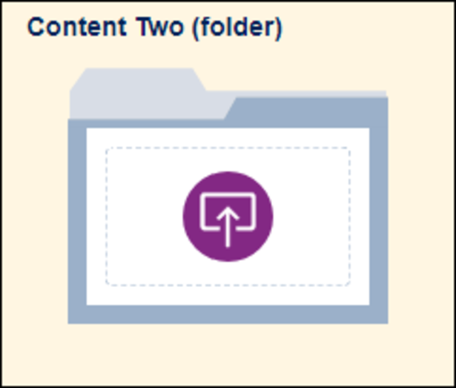

An example empty required My Activities pre-created folder

End of Figure

End of Box

## Within a folder

The first page you will come to is the Folder overview page. This page gives you an overview of the folder's contents as well information and links related to the folder.

Start of Figure

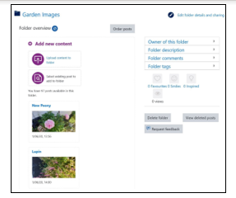

Folder overview page within My Pinboard

End of Figure

On the left-hand side of the page, previews of the posts within the folder are displayed, you are able to view one of these posts in full by clicking on the post. You are also able to add new posts to the folder or select existing posts to add to the folder using the icons here.

The post at the top of the list will be used as a thumbnail preview for the folder. If you wish to change the order of the post list, and potentially the thumbnail preview, see the Order posts within a folder section of this document.

On the right-hand side, there are several boxes that provide information and enable you to interact with the folder:

* Owner of this folder – this displays the name of the folder owner (creator) and provides a link to their work.
* Folder description – this will display any description the folder owner has given the folder. If no description is given it will display the folder's name.
* Folder comments – this allows you to comment on the folder as a whole rather than on specific posts.

Selecting Add new comment will display a text box within the comments box. Insert your comment into the text box and select Post comment. You are also able to add an audio comment if you wish by selecting the Choose a file... link underneath the 'Post an audio comment (optional)' heading.

The comment will then display within the Folder Comments box with the options to Reply or Like the comment. You are also able to delete your own comments by selecting Delete.

Start of Figure

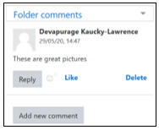

Folder comments box

End of Figure

For more information on commenting, see the Social interaction section of this guide.

* Social interaction flags – the option to leave feedback on the folder using the social interaction flags is available here. For more information see the Social interaction section of this guide.

### Edit a folder

To edit the folder title, description or visibility settings, click Edit folder details and sharing at the top-right corner of the page.

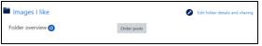

Edit folder details location

### Delete folder

### Delete folder location

Delete folder location

To delete a folder, select Delete folder from the right-hand side of the page. A pop-up box will display a message asking you to confirm the deletion. Select Delete or Cancel.

Note that deleting the folder will also delete the folder's contents and any related comments.

Start of Figure

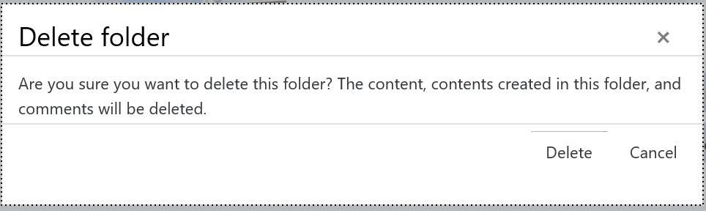

Delete folder message

End of Figure

## Add posts to a folder

There are two ways to add posts to a folder, you can either add a new post or select an existing post to add to the folder.

To carry out either option, select the appropriate icon from the top of the Folder overview page.

Start of Figure

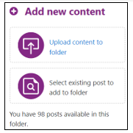

Options to upload content to a folder

End of Figure

### Add a new post

To upload posts to a folder in My Pinboard or My Activities, click on the Upload content to folder icon, or the Add new content link from the Folder overview page.

This opens the post upload form you see when uploading posts to OpenStudio, but without the visibility settings. The post will be visible to the same people who can see the folder.

### Add existing posts to a folder

You can add your own existing posts, uploaded in My Pinboard and My Activities, to a folder by selecting the Select existing post to add to folder icon.

This will display the 'Browse posts' pop-up box.

Start of Figure

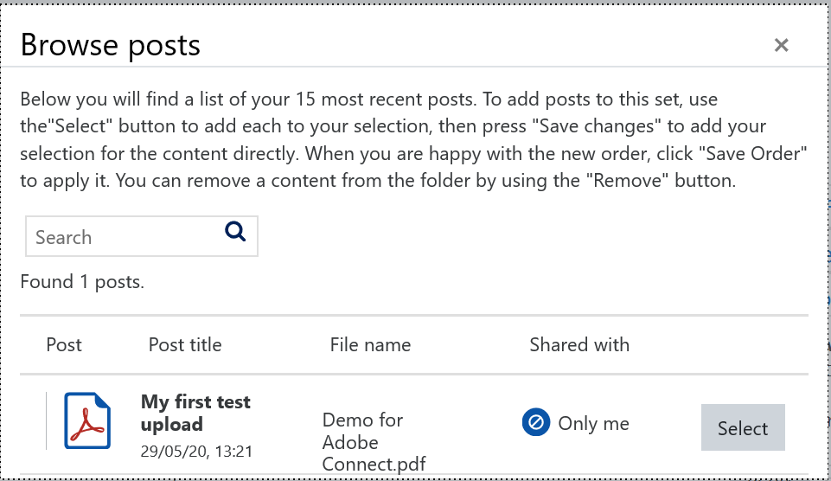

Browse posts box

End of Figure

Your first 15 posts in 'My Pinboard' are automatically listed first, but you can also use the search box displayed within the box to search for specific posts using post titles, post owner names and tags.

**Note**: there is an option to search for other people's work in OpenStudio and add their posts to your folder.

Click Select next to the posts you want to add to your folder. This displays your selected posts at the top of the box and you can add more posts and/or repeat your search until you have all the posts you wish to add.

The count next to the 'Selected posts' heading shows the number of posts you have selected and the maximum number of posts you can add.

If you change your mind and want to remove a selected post, either click on the selected post from the 'Selected posts' section at the top of the box, or select the Remove last selection button to remove the last post added.

Start of Figure

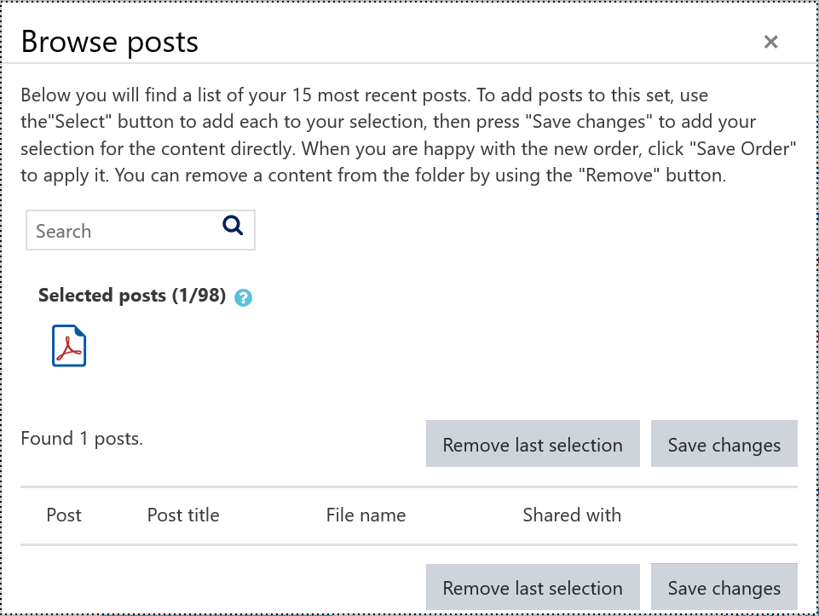Selected post within the Browse posts box

End of Figure

When you are ready to add the posts to your folder click Save changes. The posts are then automatically added to your folder.

## Order posts within a folder

## Oder posts location

Image of order posts location

You are able to change the order that the posts appear within the folder using the Order posts button, found at the top of the page.

Selecting this will bring up the 'Order posts' pop-up box.

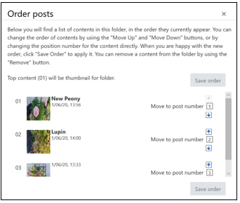Start of Figure

Order posts pop-up box

End of Figure

This will list the posts that are within the folder in the order that they will appear. On the left-hand side of each post, a number is displayed to show where it will appear in the list. On the right-hand side of each post, the number is repeated but upwards and downwards facing arrows are displayed next to each number.

Move posts up and down the list by clicking on the upwards facing and/or downwards facing arrows accordingly.

Once you are happy with the order of the posts, select Save order and the posts will now be displayed in the order you have chosen.

## Review, edit and delete content

## Review

Once you have uploaded content to your post or folder, you are taken to the post's page for review.

Start of Figure

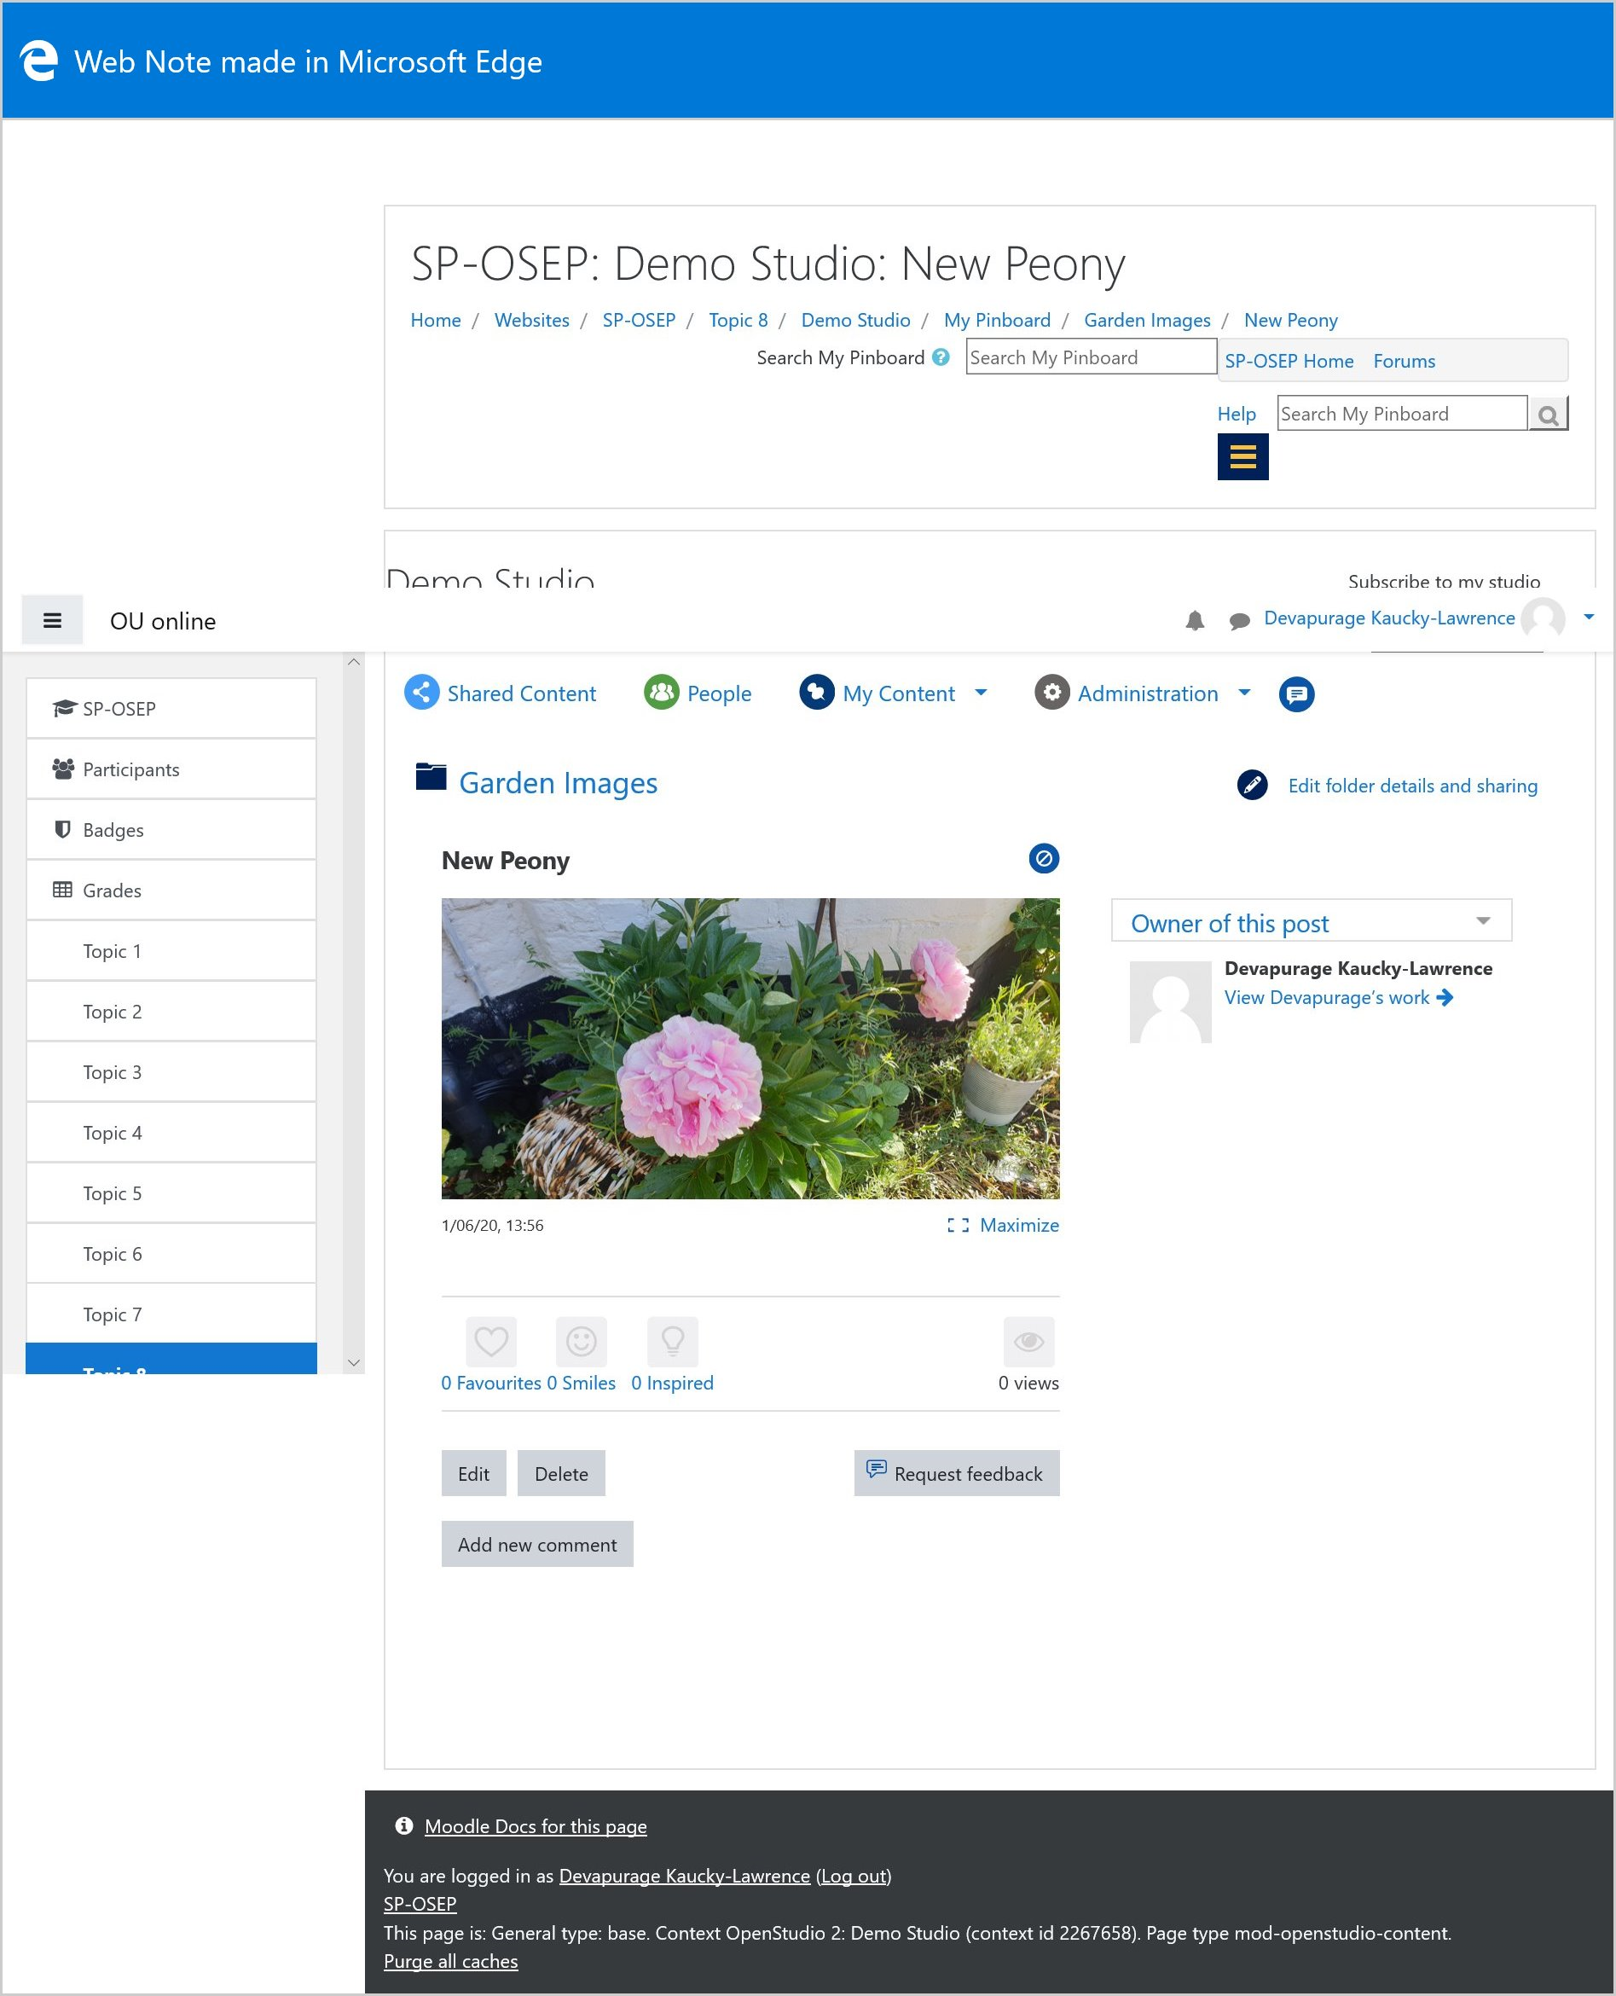

Reviewing your post

End of Figure

Depending on how your OpenStudiuo has been set up will depend on how many options you are able to see on this page. You should however be presented with at least these two buttons: Delete and Edit, ~~though this may depend on how your OpenStudio is set up~~.

* Delete – this deletes the current post if in 'My Pinboard' and deletes the content in the current post (empties the post) if in 'My Activities'. Selecting 'Delete' will display a message in a pop-up box asking you to confirm the deletion. Select Delete or Cancel.

Start of Figure

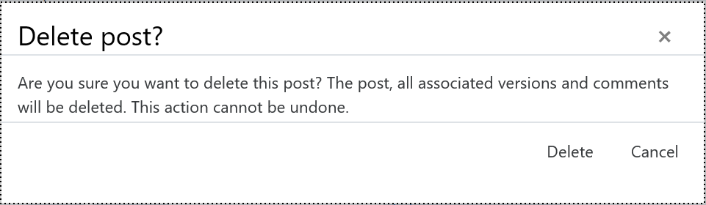

Delete post box

End of Figure

* Edit – opens the upload form for editing. You can edit the title, description, change the visibility, upload a new file, add tags, etc.

You, and if shared with your group or course, other students can also add comments by selecting Add new comment, typing into the comment box that appears and clicking Post comment. If a comment is not needed the posts can be flagged (favourites, smiles, inspired). For more information on these features, see the Social interaction section of this document.

## Versioning

If enabled in your OpenStudio, you can edit a post to delete the attached file and upload a new file. This will create a 'Post archive' containing the previous version of the post, with the previous image. The Post archive box will appear on the right-hand side of the page, where you will be able to View the archived post or Delete it. Versioning is only an option within the ‘My Activities’ slots.

Start of Figure

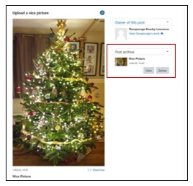

Post archiveEnd of Figure

## Restoring deleted posts

If you have been given the relevant permissions, you will be able to restore some deleted posts within OpenStudio.

### Restoring individual posts

This will only be possible where versioning has been enabled.

1. From the Post archive, select the appropriate post version you wish to restore by selecting View next to the appropriate post.
2. A screen will appear that displays that version of the post.

Start of Figure

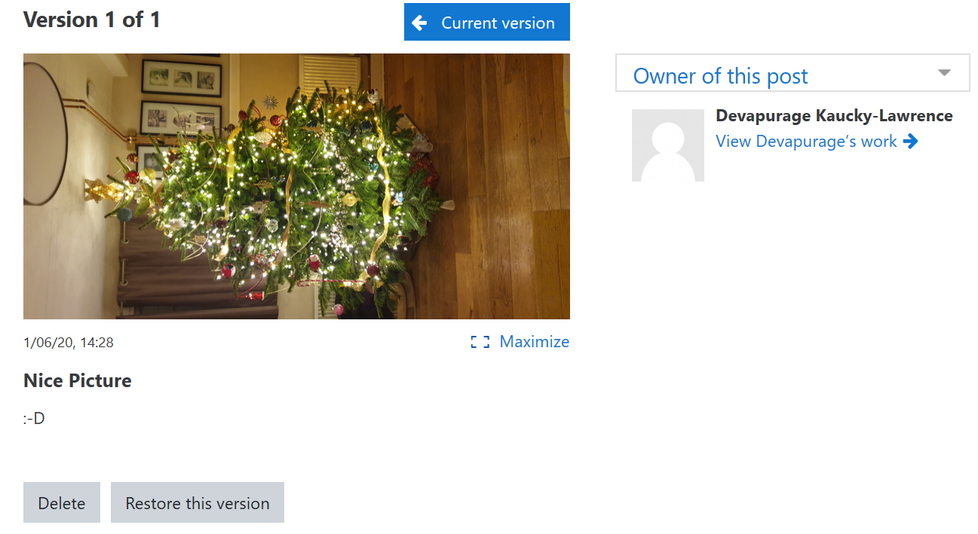

Archived post

End of Figure

1. Click on the Restore this version button.
2. The selected post version will then be restored. A new post version will also be created for the previous version of the post before it was restored. The 'last updated' information of the main version of the post will change to reflect when it was restored.
3. 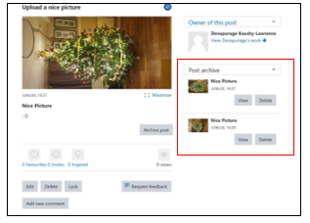Start of Figure

Restored post version

End of Figure

## Social interaction

## Feedback

### Asking for feedback

You can ask for feedback on your own content by clicking Request feedback below the content.

This will display a 'Feedback requested' message across the top of the content, which will be visible from both the content page and within a preview of the content.

If turned on, other people will also be able to see the 'Feedback requested' message.

Start of Figure

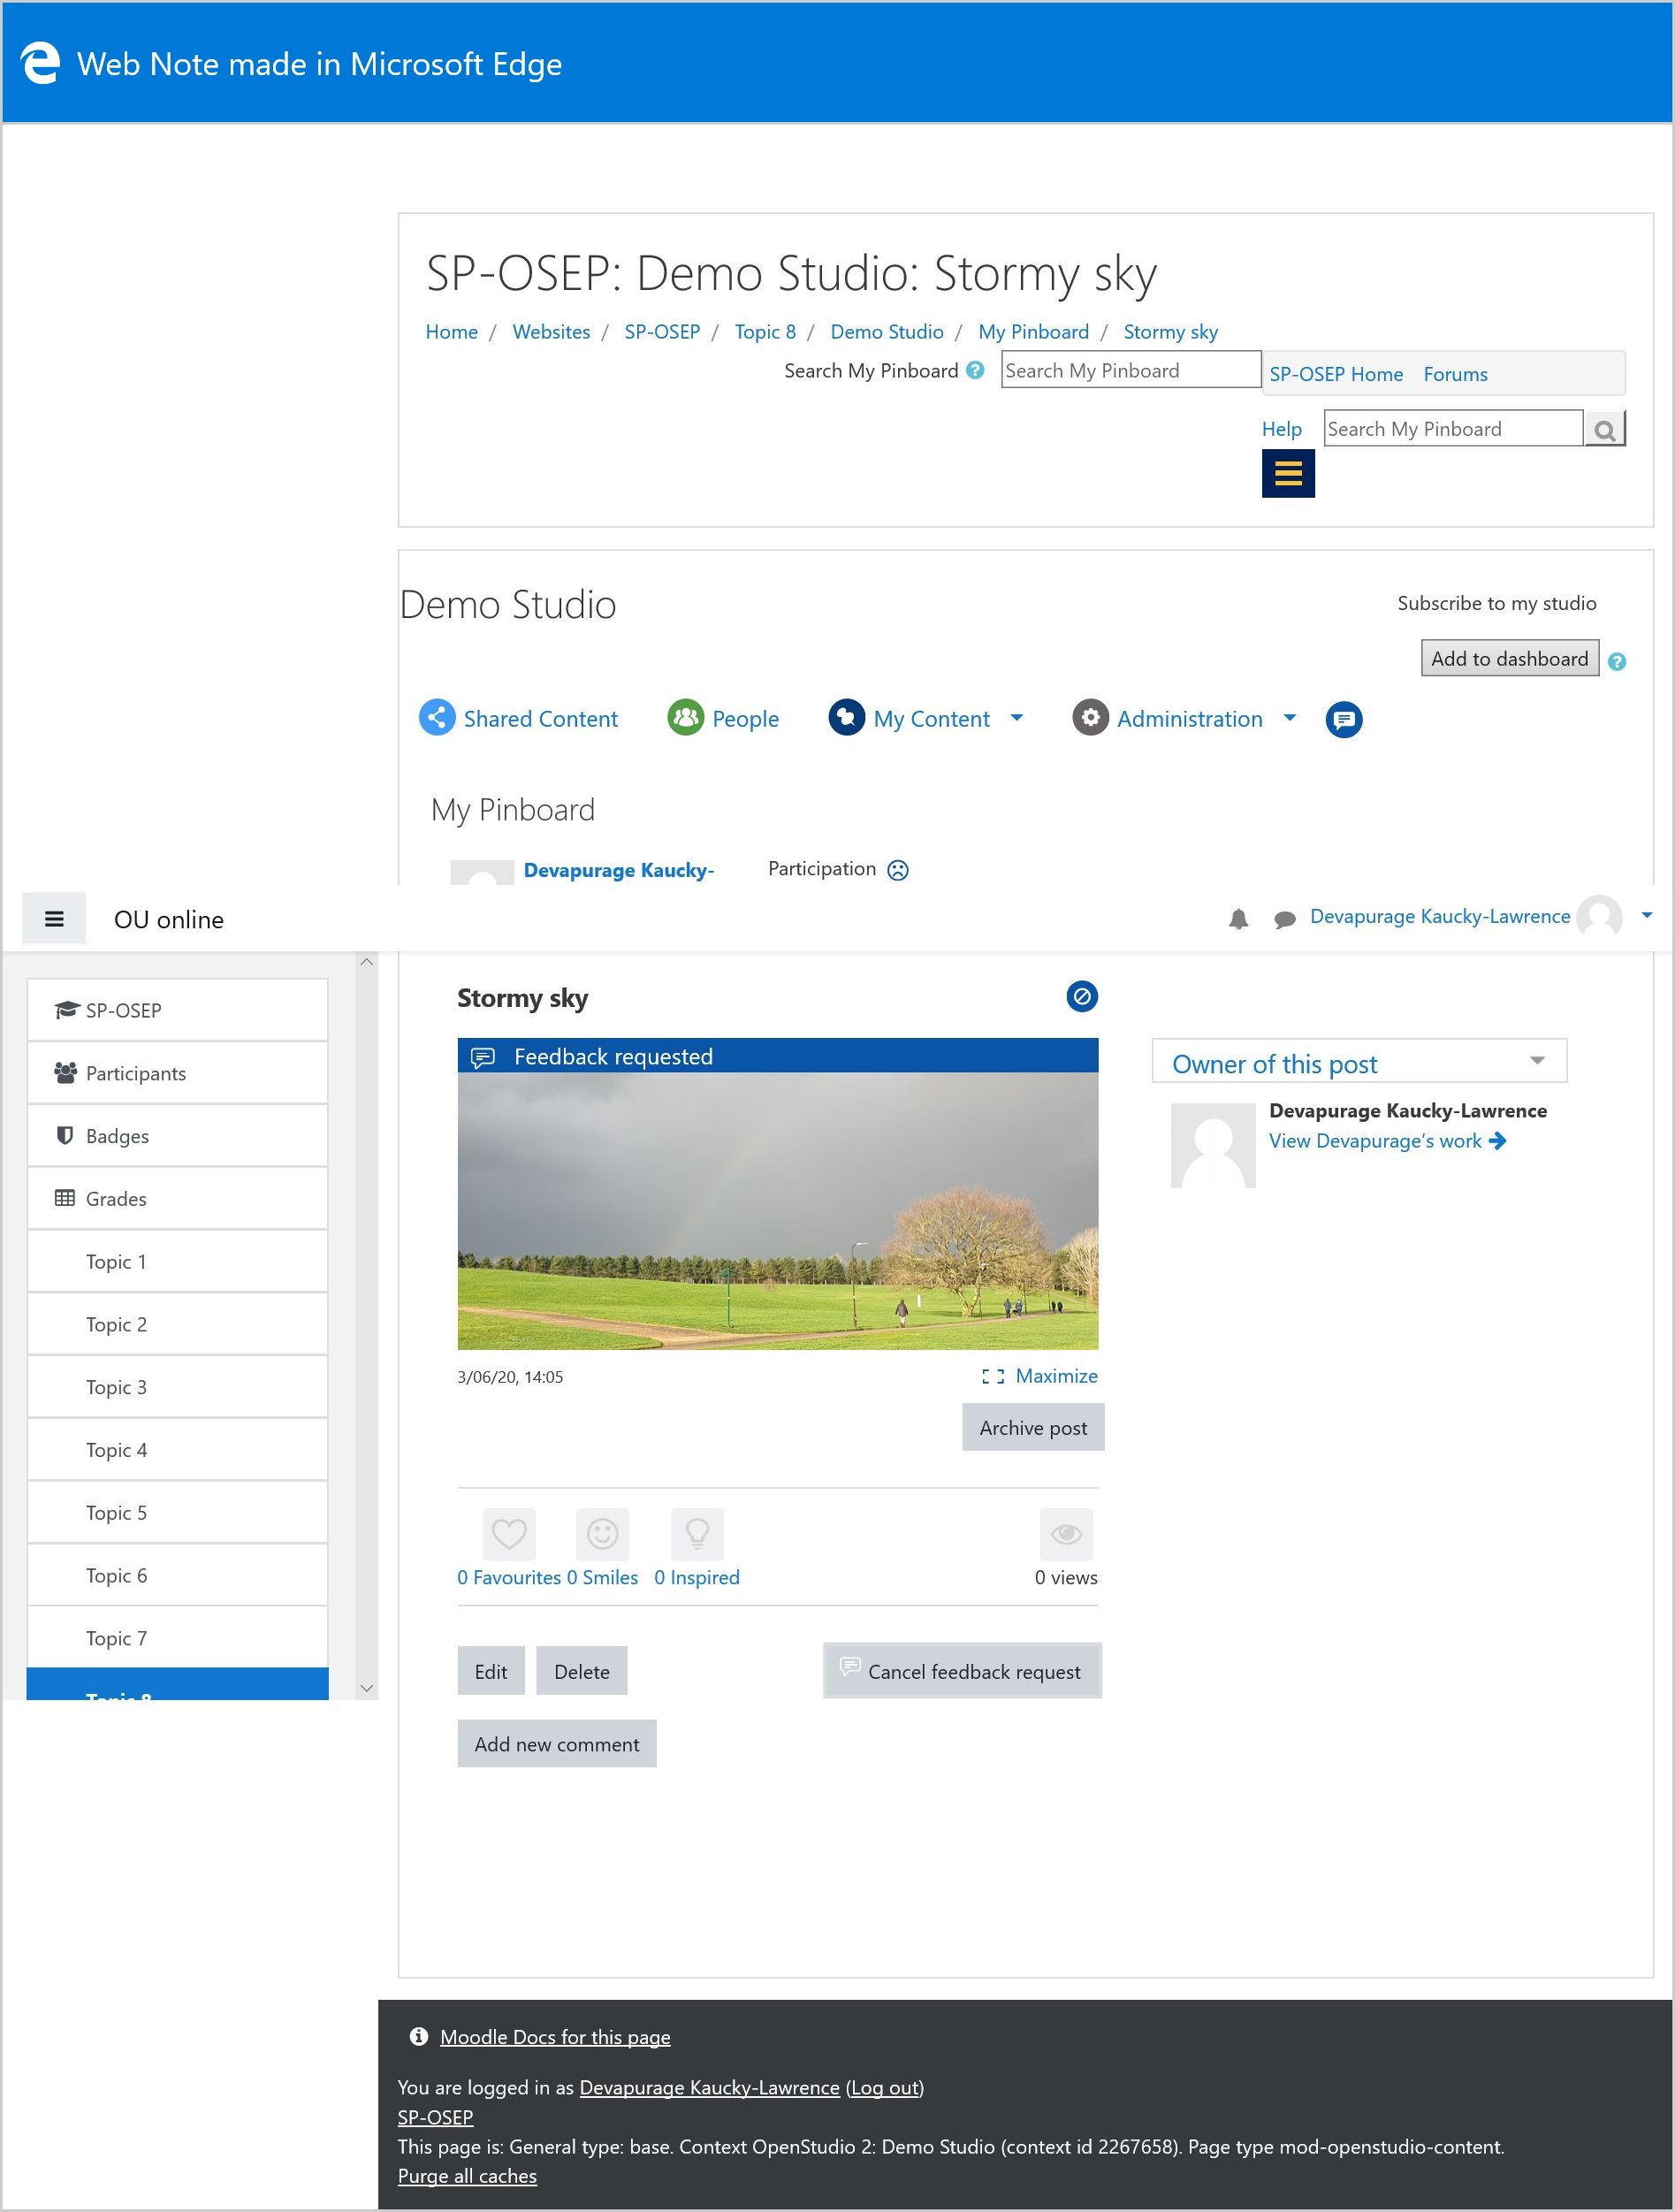

Post preview with feedback requested

End of Figure

Start of Figure

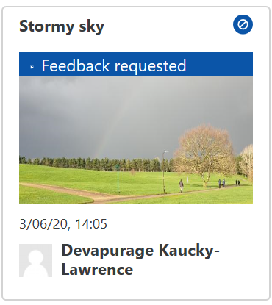

Post with feedback requested

End of Figure

You can cancel this request by clicking Cancel feedback request from the content's page.

## Commenting

You can provide feedback by commenting on posts shared by other students by selecting the Add new comment button located underneath a selected image. You can also comment on a folder of work; the comments box is to the right of the folder image.

By selecting Add new comment, a text box will appear where you can insert your comments.

Type your comment or feedback into the comment box and click Post comment

Start of Figure

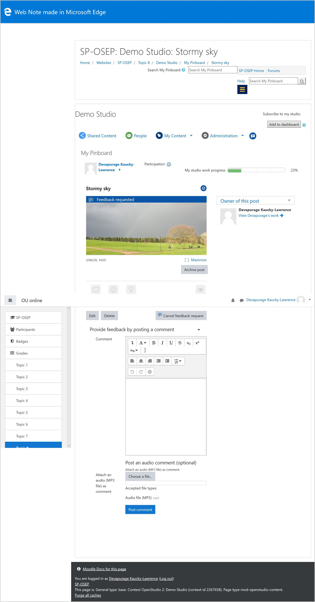

Commenting on a post

End of Figure

There is also the option to leave feedback using an audio clip. To do this, click Choose a file and upload an audio file (see Supported file types). Note that this is only a way of uploading a pre-existing audio file and not a means of recording an audio comment.

You can delete your own comments at any time by using the Delete comment link.

It is also possible to reply to comments. This can be done in two ways, by 'liking' a comment, using the Like comment link, or by clicking the Reply button, which will display a text box to type in.

Start of Figure

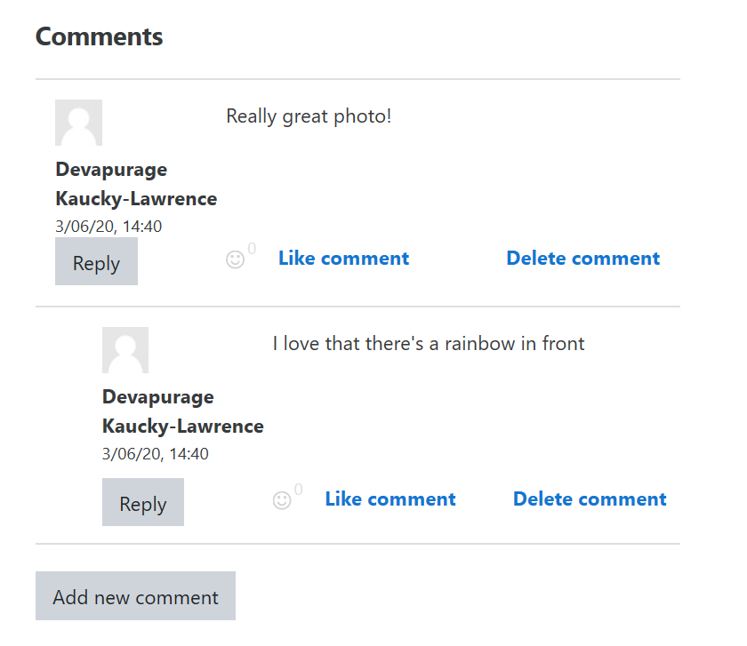

Replying to a comment

End of Figure

## Flags

Flags are a way of providing feedback without having to leave a comment by selecting one of the options provided.

There are three flags: 'Favourites', 'Smiles' and 'Inspired'. You can choose to select one or more of these flags, or none of them.

You can add a 'Favourite', 'Smile' or 'Inspired' by clicking on the icon of the flag/s. Click the icon again to remove your flag.

Start of Figure

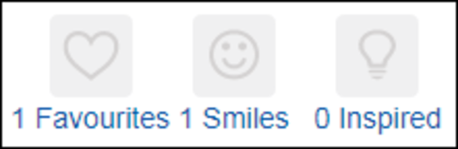

Flags available in most posts

End of Figure

'Views' is a counter that reports how many people have looked at the post. 'Copies' is a counter that reports how many copies of the post exist (this will show if a post has been added to a folder elsewhere).

Start of Figure

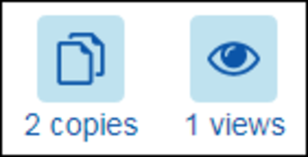

Views and copies

End of Figure

## Reporting posts

You are able to report abusive posts to a member of staff using the Report post link on a post's page.

Start of Box

Please use this feature only if the content is offensive or you encounter something you think breaks the [OU Computing Policy](https://learn1.open.ac.uk/mod/oucontent/olinkremote.php?website=CG&targetdoc=Computing%20codes%20of%20conduct).

End of Box

Selecting this link will display the 'Report Abuse' form where you can state a reason for reporting the post and provide other information.

The options are reporting a post are as follows:

* it is abusive
* it is harassment
* it contains obscene content such as pornography
* it is libellous or defamatory
* it infringes copyright
* it is against the rules for some other reason.

Select the appropriate option/s and then use the 'Other information' text box to explain why you are reporting the post.

Start of Figure

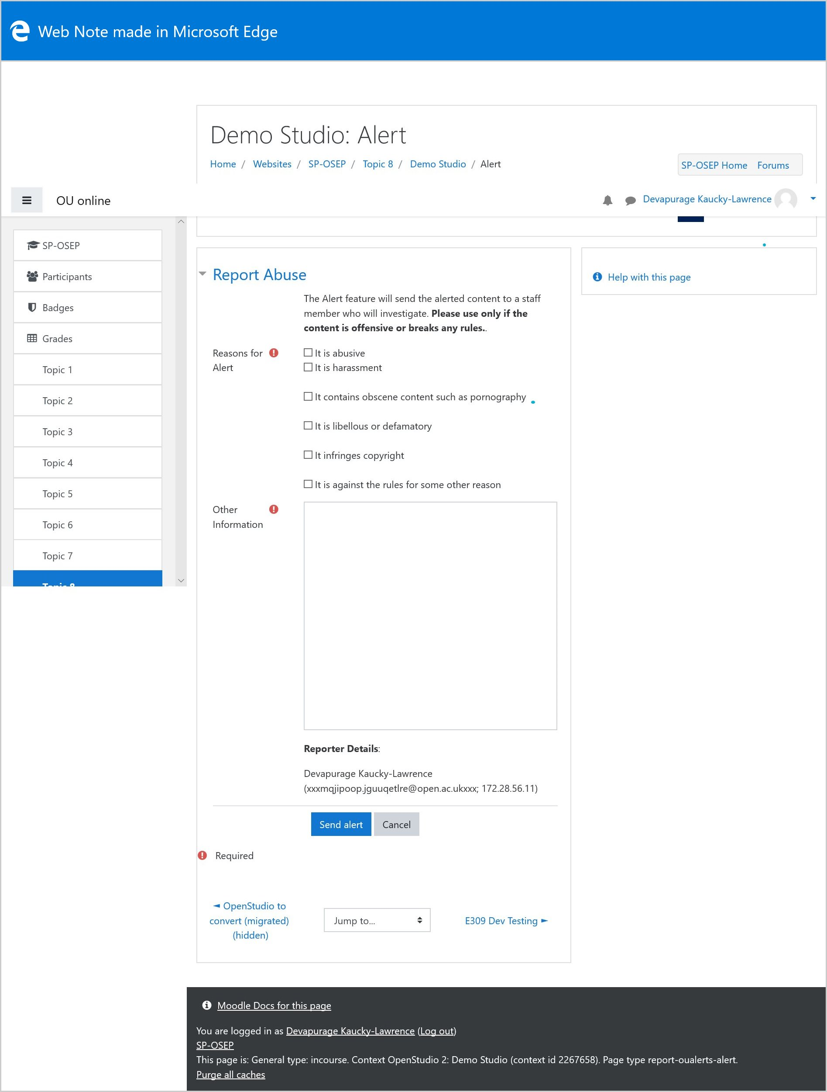

Report Abuse form

End of Figure

Once you have filled out the form, select Send alert to report the post, or Cancel to cancel the process.

## Notifications

When someone leaves a comment or flags a post of yours, the Notification icon at the top of the page will display a number in a red circle. This number indicates the number of notifications you have.

Start of Figure

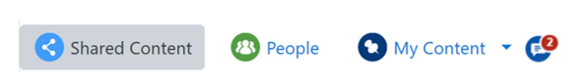

Notification icon displaying notifications

End of Figure

Clicking on the Notification icon will display a pop-up box that will list the details of your notifications. Click on the link to the post within the notification to view the post and any comments or flags that have been left.

Start of Figure

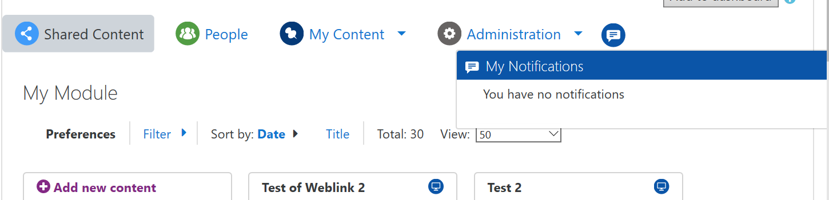

Notification pop-up box

End of Figure

New notifications are displayed with a blue background, with viewed notifications displayed with a white background.

When there are more than seven notifications, a scroll bar will appear on the right-hand side of the notification pop-up box to navigate to older or read notifications.

You are also able to see notifications by viewing the post from one of the studio areas. The appropriate flag or comment icon (depending on the notification) will be highlighted in blue, with a red circle containing the number of notifications displayed in the top right-hand corner of the appropriate icons.

Start of Figure

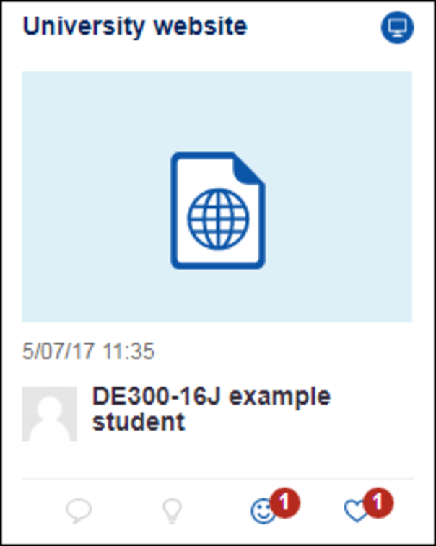

Notifications for a post

End of Figure

Viewing the post will mark it as read. This will turn the notification background white when being viewed in the notification pop-up box, and will clear the red circle icon for that notification.

When you select the Notification icon, the number within the red circle will disappear. Your notifications will still be visible from the Notification icon, they will just not be highlighted using the red circle here.

However, until you view the post, the preview of the post visible from one of the area pages will still contain the red circle and number in the top right-hand corner of the appropriate flag or comment icons.

For more information on commenting or flagging a post, see the Social interaction section of this document.

## Folder notifications

When posts are within a folder, the notifications for these posts (red circle and number above the appropriate icon) will not appear on the folder thumbnail visible from one of the area pages or when viewing the posts within the folder.

Notifications for these posts will still be visible using the Notification icon (unless hidden) as they would for posts outside a folder.

If a user has flagged the folder itself, these notifications will appear when viewing the folder from one of the area pages.

Start of Figure

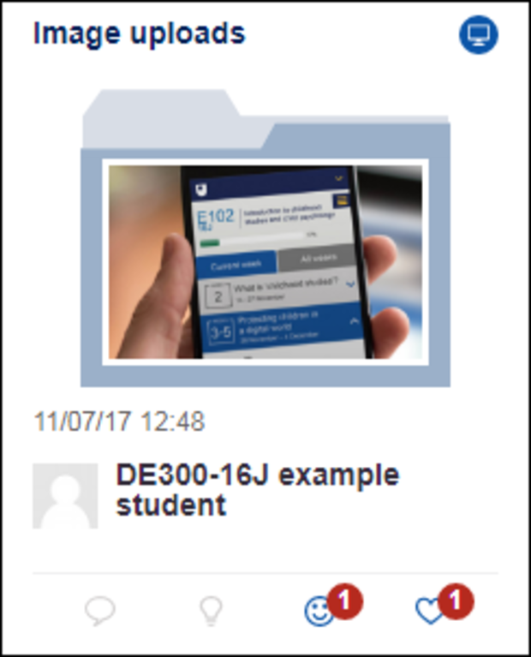

Folder notifications

End of Figure

## Hiding notifications

Start of Box

Note that you are **not** able to turn content notifications back on for anything that you have hidden. Consider this carefully before hiding content notifications.

End of Box

Within the Notifications pop-up box, an eye icon is displayed next to notifications. This is the Stop notifications icon.

Start of Figure

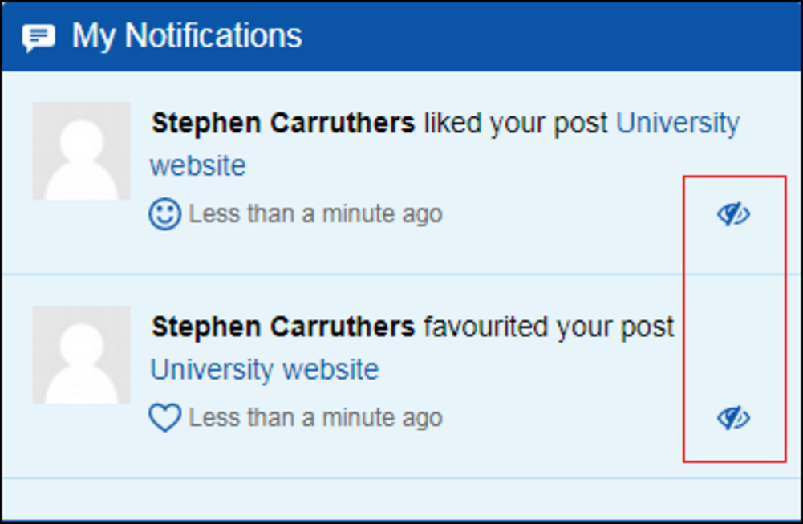

Stop notifications icon

End of Figure

Clicking the Stop notifications icon will stop future notifications for the action mentioned in that notification. For example, if you click the icon for a notification telling you that someone has liked your post, you will not receive any more notifications for people liking that post.

When you click on a Stop notifications icon, a pop-up message will appear asking you to confirm that you wish to stop notifications for that action for that post. Select Stop notifications or Cancel.

Start of Figure

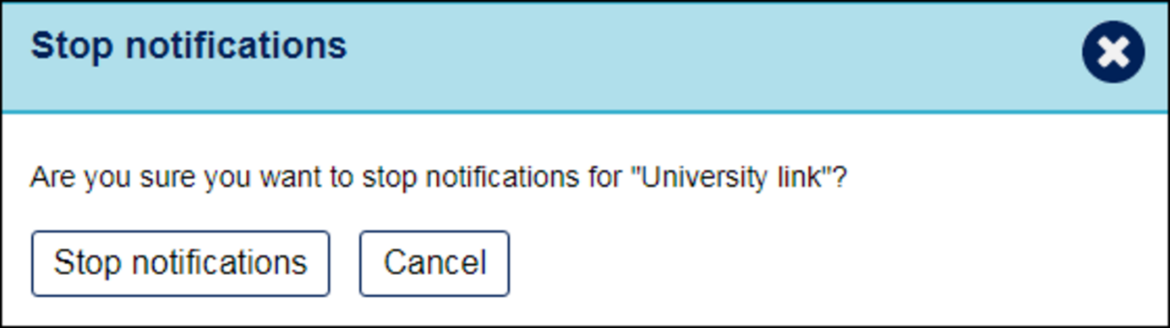

Stop notifications message

End of Figure

Once Stop notifications has been selected, you will no longer receive notifications for that action for that post. The Stop notifications icon will also no longer appear for that action within any existing notifications for that post.

Start of Figure

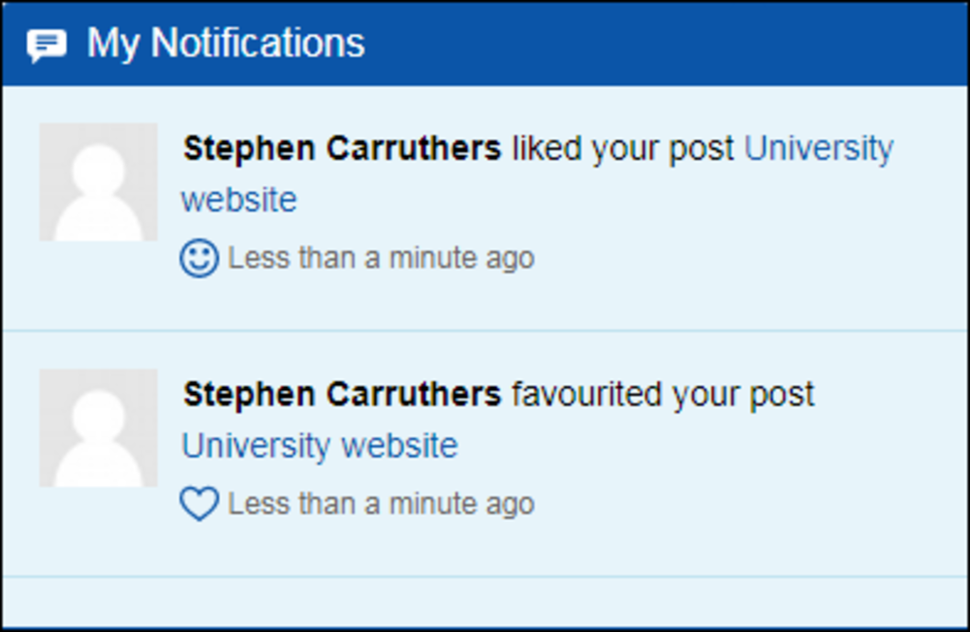

Notifications with no Stop notifications icon

End of Figure

## Email subscription

At the top the page when using OpenStudio, a Subscribe to my studio button will enable you to receive updates about new content via email.

To subscribe, click the Subscribe to my studio button at the top right-hand side of the page. This will bring up the Subscription settings pop-up box.

Start of Figure

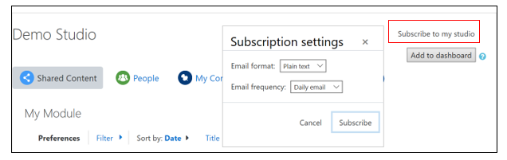

Subscription settings

End of Figure

Specify whether you wish to receive the email as plain or formatted text and whether you want an hourly or daily email, then click Subscribe.

Once you have subscribed, the subscription button will change to read Unsubscribe. Select this to stop receiving email updates.

## Locked posts and folders

Your OpenStudio may include posts or folders that can be locked. Locking is set either automatically as part of the set up by your teacher to open and close on specific dates (this will be indicated in your teaching material), or manually by admin if required.

When a post or folder has been locked, a 'Post locked' message with a padlock icon is displayed across the top of the content, which will be visible from both the content page and within a preview of the content..

Start of Figure

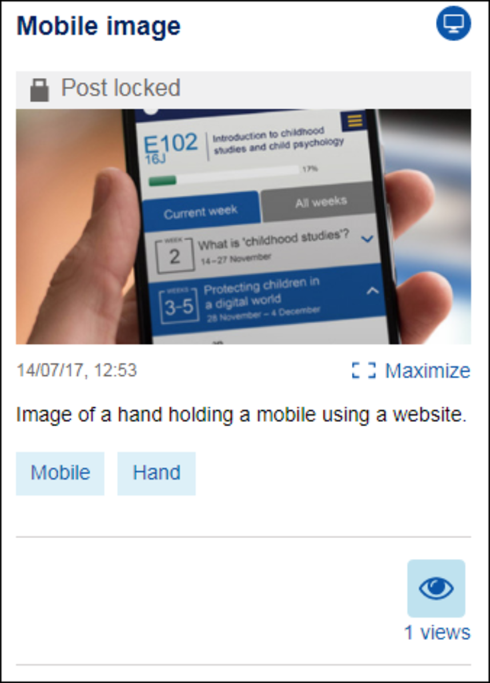

Locked post

End of Figure

Start of Figure

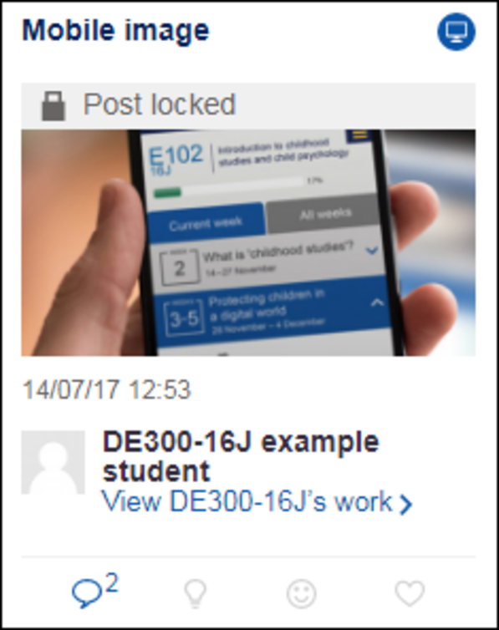

Locked post preview

End of Figure

If your teacher has set up your post or folder to be locked at a specific date and time, you will see a message (such as the one below) telling you when it will be locked.

Start of Figure

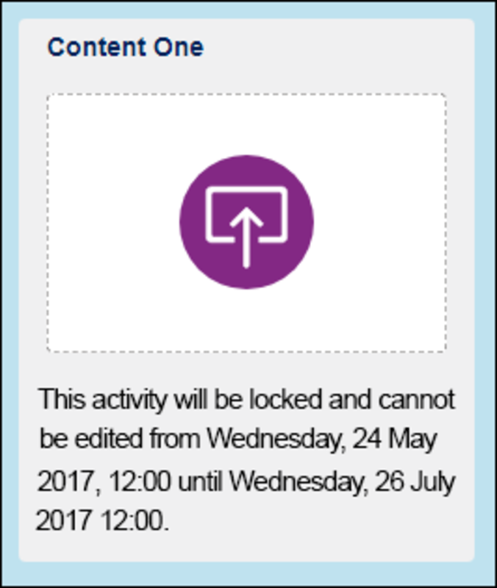

Date and time of post/folder locking

End of Figure

## 

## Filters

You are able to use various filter options to change what is being displayed in your OpenStudio.

There are two 'quick sort' functions, which can be found at the top of the page within the preferences menu:

* by the date posts were last edited
* by the title of the posts.

To access more filters, click on the downwards facing arrow.

Start of Figure

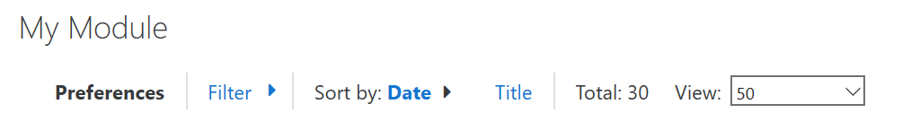

Unexpanded filter bar

End of Figure

This will expand the filter bar to display the advanced filter options.

Start of Figure

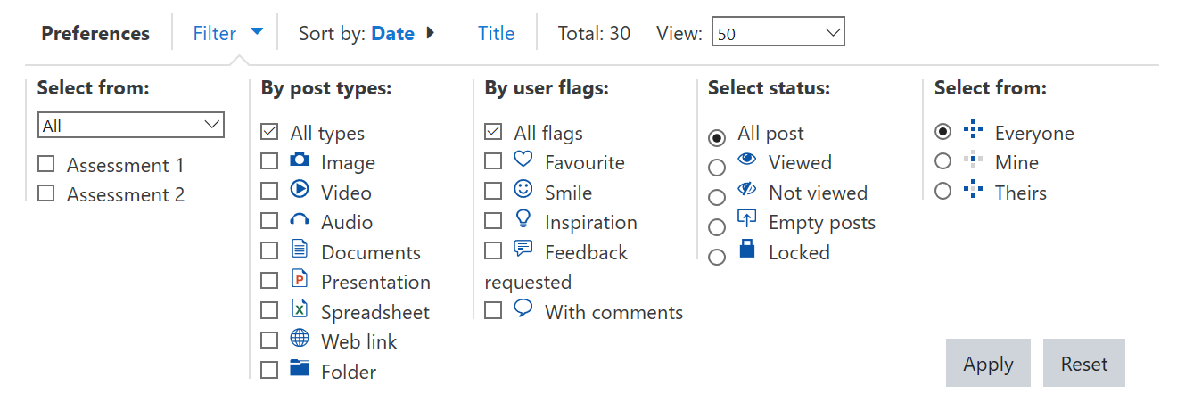

Expanded filter menu

End of Figure

The filter menu allows you include or exclude posts based on the criteria you set. From left to right, you can filter by:

* block
* file type
* user flags
* post status
* point of view.

Choose your criteria (either single or multiple) and click Apply to see the posts that meet your criteria. Click Reset to clear the filter(s) and reset your view.

Start of Box

**My Activities**

If your course uses My Activities, the view can be filtered by block.. The My Activities homepage defaults to show all blocks. Use the 'Work' drop-down menu to select which block posts you want to view.

Start of Figure

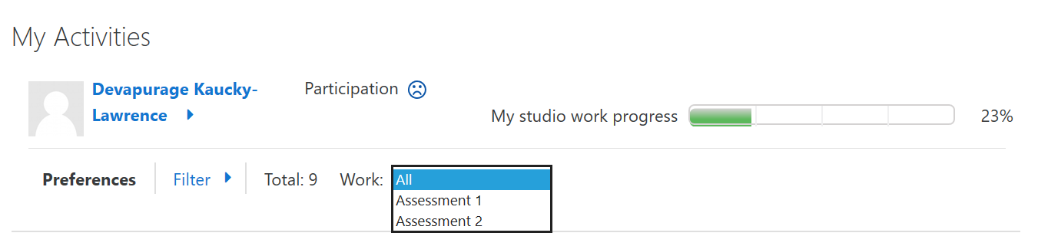

Filter by block in My Activities

End of Figure

End of Box

Start of Box

**Filtering by comments**

As part of assessed work, you may be asked to submit proof of that you have either commented on other people's work, or that other people have commented on your work.

**Filtering posts to find comments from others**

This is usually done through My Activities.

1. Open Filters. If there are any active filters, select Reset and reopen the filter bar.
2. If you need to filter within a particular block, select the appropriate block from the 'Work' drop-down menu. Otherwise, select All.

If you need to filter particular file types, such as images only, select the relevant file type.

1. From the 'By user flags' options, select With comments.
2. Under 'Select from', select Theirs.
3. Click Apply.

Your work should now be filtered to only display the items that other people have commented on.

**Filtering posts you've commented on**

This is usually done through My Group within 'Shared Content'.

1. Open Filter options. If there are any active filters, click Reset and reopen the filter bar.
2. If you need to filter within a particular block, select the appropriate block from the 'Work' drop-down menu. Otherwise, select All.

If you need to filter particular file types, such as images only, select the relevant file type.

1. From the 'By user flags' options, select With comments.
2. Under 'Select from', select Mine.
3. Click Apply.

Other peoples' shared work in your group should now be filtered to display the items that you have commented on.

End of Box

## Export and import

## Export

You are able to export content that has been uploaded to the 'My Activities' and 'My Pinboard' areas by clicking on the Export icon.

The Export icon can be found at the bottom of the 'My Activities' and 'My Pinboard' areas. End of Figure

Start of Box

Note that you are only able to export content that has been uploaded to the 'My Activities' and 'My Pinboard' areas. You are not able to export the work of others from the 'Shared Content' tab.

End of Box

Clicking on the Export icon will display the 'Export posts' pop-up box where you can choose to export All content shown on the page, or Selected posts.

Start of Figure

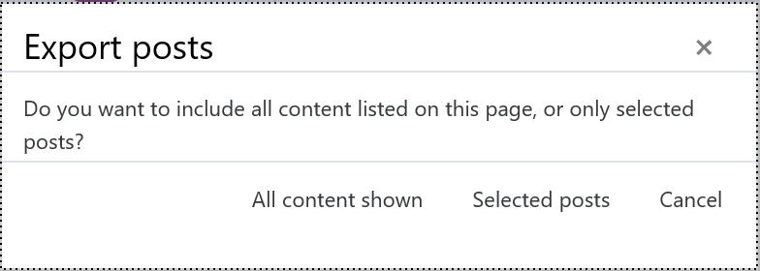

Export posts pop-up boxEnd of Figure

Clicking on Selected posts will take you to the 'Export posts' page and selecting All content shown will take you to the 'Select export type' page.

### Export posts – selected posts

The Export posts page will list all posts that were displayed on the page when the Export icon was selected in table form.

Start of Figure

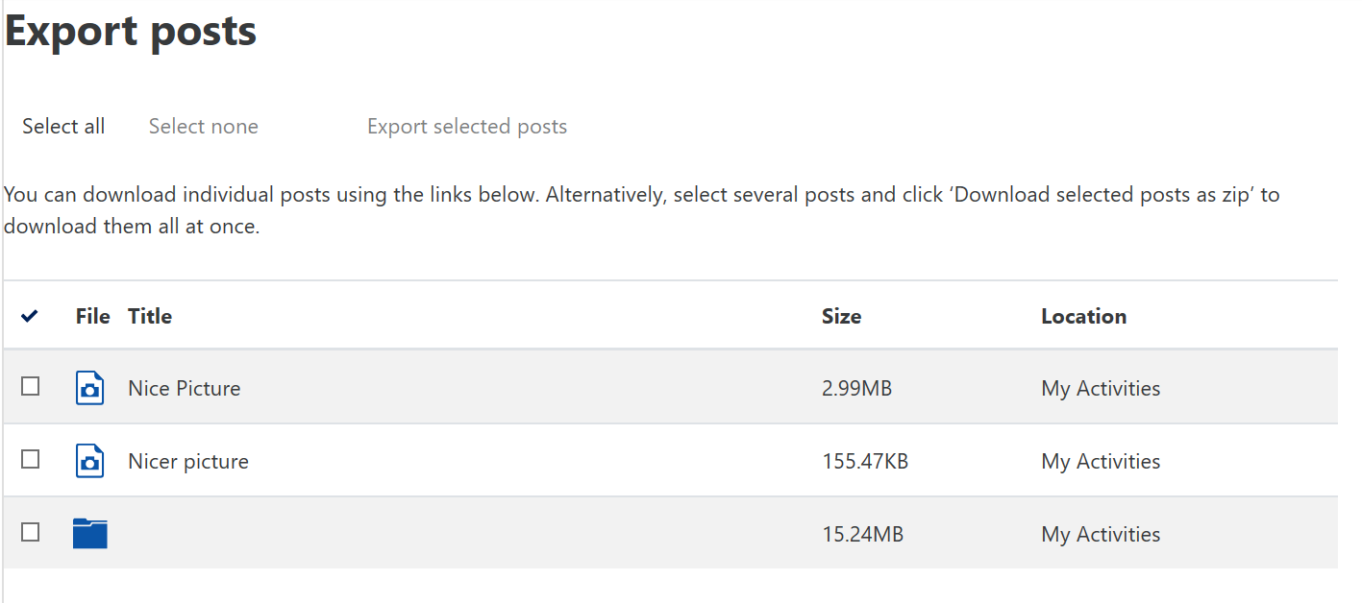

Export posts pageEnd of Figure

Select posts by using the check box next to individual posts or click on the Select all button. To cancel your selection, click on the Select none button.

When you have finished selecting the posts, click on Export selected posts to navigate to the 'Select export type' page.

### Select export type

Use the drop-down menu to select the type of file you wish to export:

* File download – a zip file containing all files you have selected. More information on zip files can be found in the [Compressing files (including working with .zip files)](https://learn1.open.ac.uk/mod/oucontent/olinkremote.php?website=CG&targetdoc=Compressing%20files%20(including%20working%20with%20.zip%20files)) document.
* RTF download – a Rich Text Document containing text, images and links for other file formats.

Start of Figure

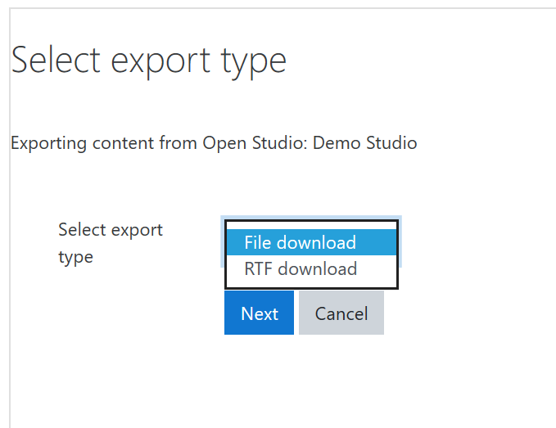

Export type page

End of Figure

Once you have selected the type of file, click on Next to begin downloading the file. Remember to save the file somewhere easy to find (such as your computer desktop).

## Import

You can import a number of different files to multiple posts by uploading them as a single zip file. Note that the zip can contain unsupported file types - but you won't be able to create posts for them once uploaded.

The 'Import' button can be found at the bottom of the 'My Pinboard' area.

Start of FigureEnd of Figure

Start of Box

Note only zip files are accepted. Collect your various files and compress them into one zip file to upload and import. More information on zip files can be found in the [Compressing files (including working with .zip files)](https://learn1.open.ac.uk/mod/oucontent/olinkremote.php?website=CG&targetdoc=Compressing%20files%20(including%20working%20with%20.zip%20files)) document.

End of Box

1. Click Import.
2. This will bring up the Import screen.

Start of Figure

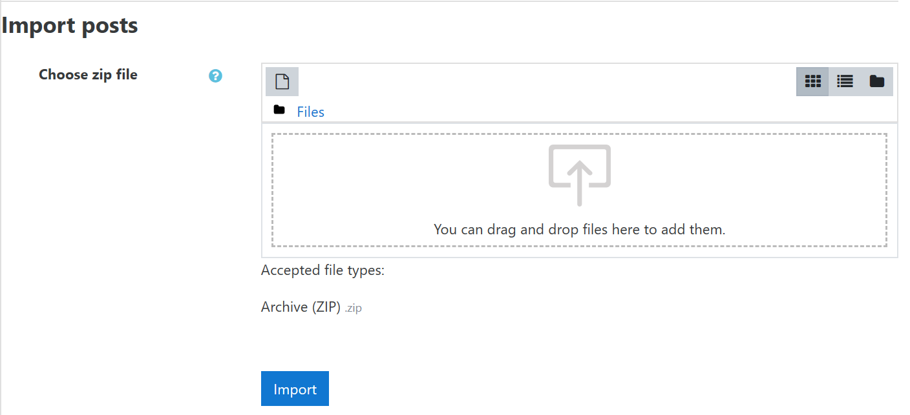

Import screenEnd of Figure

If your web browser supports 'drag and drop' file upload, select and drop your files into the rectangular drop area. Otherwise click on the 'Add file' icon and upload your file that way. Further information can be found in the 'File uploader' section of the [Text editor](https://learn1.open.ac.uk/mod/oucontent/olinkremote.php?website=CG&targetdoc=Text%20editor) document.

1. The file will be displayed in the upload box.

Once the .zip file is uploaded, click Import.

1. Your files will now be uploaded as one new post for each file. Don't forget to view each one and add any additional information if you want (see Review, edit and delete content).

## Teachers: multiple groups

Teachers with access to more than one group will see a group drop-down menu in the preferences menu bar. Select the desired group from the menu to display that groups posts.

Start of Figure

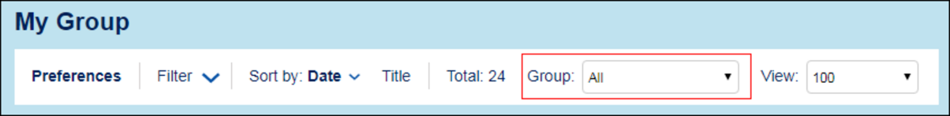

Group drop-down menu

End of Figure

## Using OpenStudio on a mobile device

When using OpenStudio on a mobile device, although it may look a little different, you are able to use it in much the same way that you would ordinarily.

Start of Figure

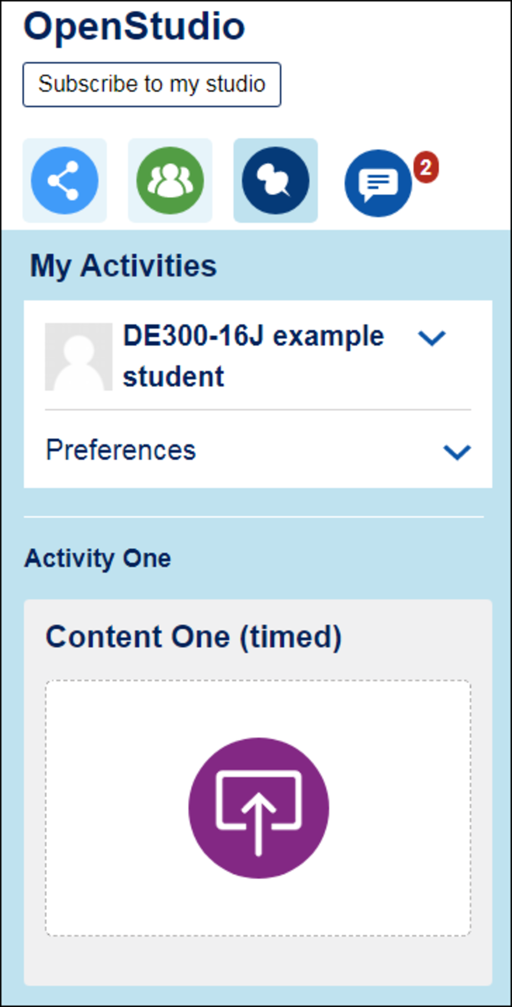

How OpenStudio might look on a mobile deviceEnd of Figure

Depending on the screen size of your mobile device, some aspects of OpenStudio may not be visible and some pages may end up being very long. Your device may also not have the ability to carry out all of the functions available within OpenStudio. See below for potential differences when using OpenStudio on a mobile device.

## Filter options

Depending on the screen size of your mobile device, you may also not be able to use all of the filter options available, but you should still be able to use the ‘Sort by’ function.

## Text editor

Some functionality of the text editor may not be visible when using OpenStudio on a mobile device. Options that may not be initially visible when using the text editor are as follows:

* alignment and indenting
* undo and redo functions
* ability to insert: special characters, equations, tables
* font and background colour
* clear formatting
* view HTML.

To view these options, select the ‘Show more buttons’ icon in the top left-hand corner of the text editor.

## Attachments

Uploading attachments to posts may not be possible depending on the mobile device being used. When possible, what you are able to upload and where you are able to upload from may depend on your device and operating system. You may wish to consult the user manual for your mobile device.

For information on how to add attachments, see the [Attachments](https://learn1.open.ac.uk/mod/oucontent/olinkremote.php?website=CG&targetdoc=Text%20editor%20(Atto)&targetptr=9.1) section of the [Text editor](https://learn1.open.ac.uk/mod/oucontent/olinkremote.php?website=CG&targetdoc=Text%20editor) document.

## Exporting and importing

Depending on the mobile device being used and the file type chosen for exporting/importing, you may not be able to view or download file exports.

For more information, see the Export and import section of this guide.

End of Box

## Accessibility

Every effort has been made to make OpenStudio accessible for all users.

Reading OpenStudio pages is reasonably accessible, but attaching content (e.g. image files) or adding comments (both of which use the [Text editor](https://learn1.open.ac.uk/mod/oucontent/olinkremote.php?website=CG&targetdoc=Text%20editors:%20general%20information)) may be less so. The accessibility depends on the task being carried out. End of Box

## Colour settings

If you have difficulty with the colours used by OpenStudio, you can set your browser to ignore the colours. In Internet Explorer you can do this by:

1. Go to the Tools menu and select Internet Options
2. Then select Accessibility
3. Choose the option Ignore colours specified on web page

Alternatively you can choose the colours you prefer for background, text and links on web pages. To do this in Internet Explorer:

1. Go to the Tools menu and select Internet Options
2. Then select Colours
3. Uncheck the 'Use Windows colours' and use the other options to select your preferred colours.

## Large fonts

Changing the font size without altering the surrounding controls will make the text size incompatible with the rest of the screen. Please use the browser zoom features (usually Ctrl + + and Ctrl + -) instead.

# 